What is cloud computing?

Cloud Computing
Accessing computing services (servers, storage, software) over the internet, provided and managed by a third party. You use what you need, when you need it, without owning any hardware.

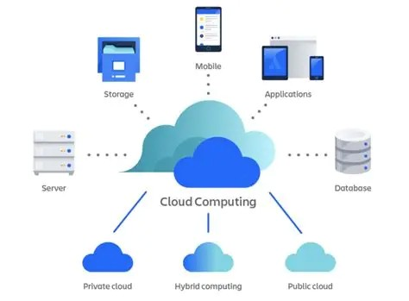

What is traditional computing?

Traditional Computing
Running software and storing data on physical hardware you own and maintain locally; like a desktop PC or a company's own server room. Everything lives on-site.

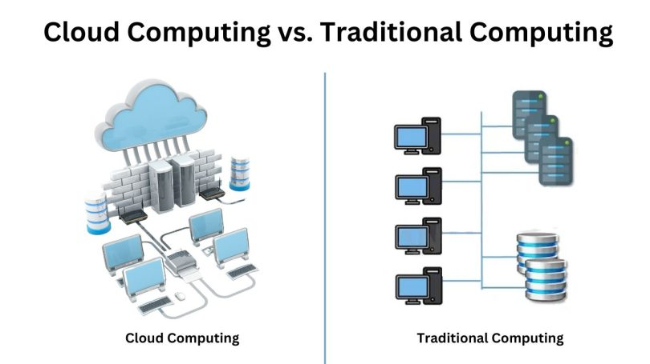

Cost comparison

CLOUD COMPUTING
Pay-as-you-go
Subscription or usage-based billing
- Low upfront cost - no hardware to buy
- Monthly or annual subscription fees
- Scale up or down based on usage
- Provider handles maintenance costs

Real-world example: Microsoft 365 subscription - R219/month per user, no servers needed.

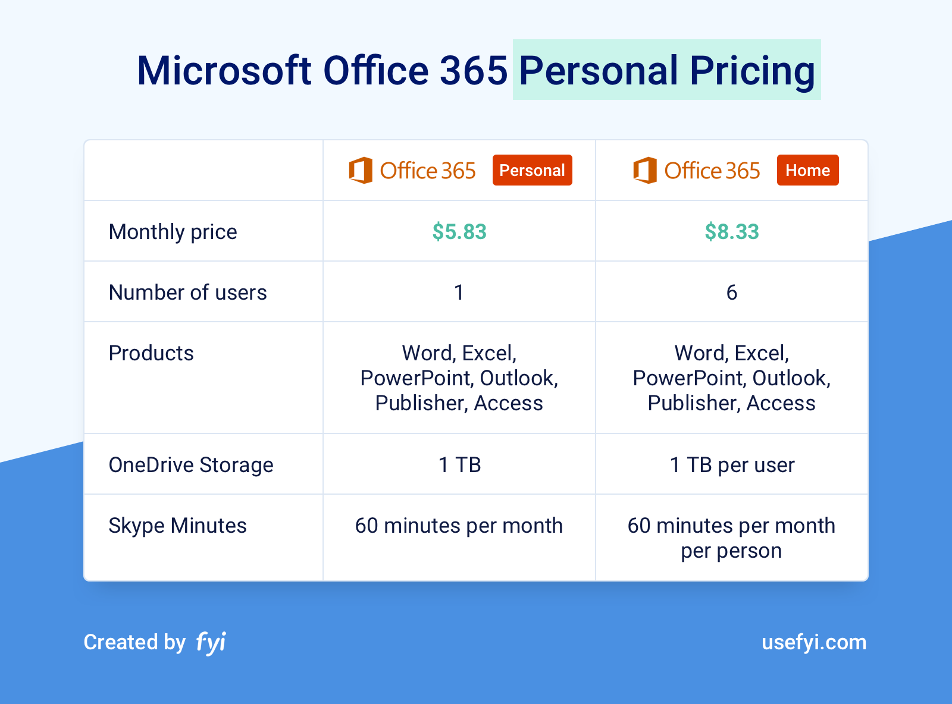

TRADITIONAL COMPUTING
One-time purchase
Large upfront capital investment
- High initial cost for hardware/software licences
- Ongoing maintenance and IT staff costs
- Upgrading means buying new equipment
- Fixed capacity - pay for max, not actual use

Real-world example: Buying Microsoft Office once (R3 500+) and installing it on a single PC.
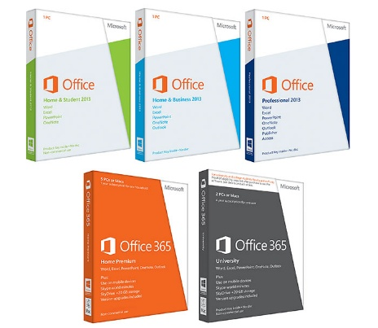

Cloud Computing vs Traditional Computing Costs

